
MATHS METHODS (CAS) UNITS 1 & 2
TRIAL EXAM 1
SOLUTIONS
2008

Question 1

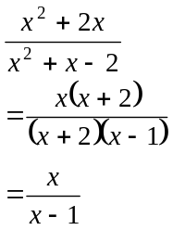
(1 mark)

Question 2

The graph of 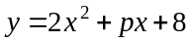 is the graph of a parabola.
It will touch the x-axis just once if there is one solution to the equation 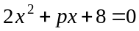 (since 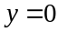 is the equation of the x-axis).
There is one solution when
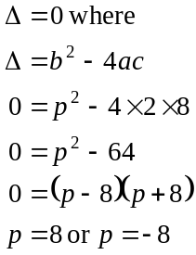
(1 mark)
So 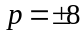
(1 mark)

Question 3

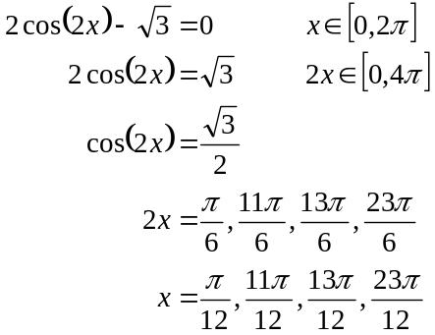(1 mark)

(1 mark) for first two correct answers (1 mark) for second two correct answers

Question 4

- From the graph, we see that 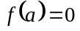. That is, when , the value of the function is zero. Another way of thinking of it is that the graph of the function passes through the point 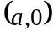.
(1 mark)

- 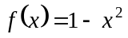
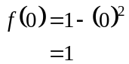
(1 mark)

- The x-intercepts of the graph of occur at 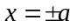 when 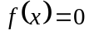.
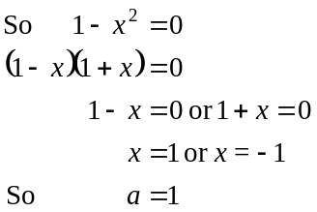
(1 mark)

- Method 1 – using the discriminant for the quadratic function
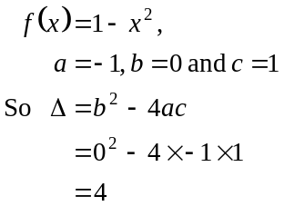
Since , the graph of crosses the x-axis twice.
(1 mark)
Method 2 – otherwise
The graph of the function is an inverted parabola that has been translated 1 unit vertically upwards so that its turning point occurs at the point 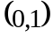. It therefore must cross the x-axis twice.
(1 mark)

- From the graph, the gradient is greatest at (or 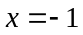 since from part c. we know that 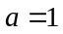). The gradient decreases until at , the gradient is zero. Note we are looking at a restricted domain of 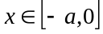.
For the gradient would be greater than at .
(1 mark)

Question 5

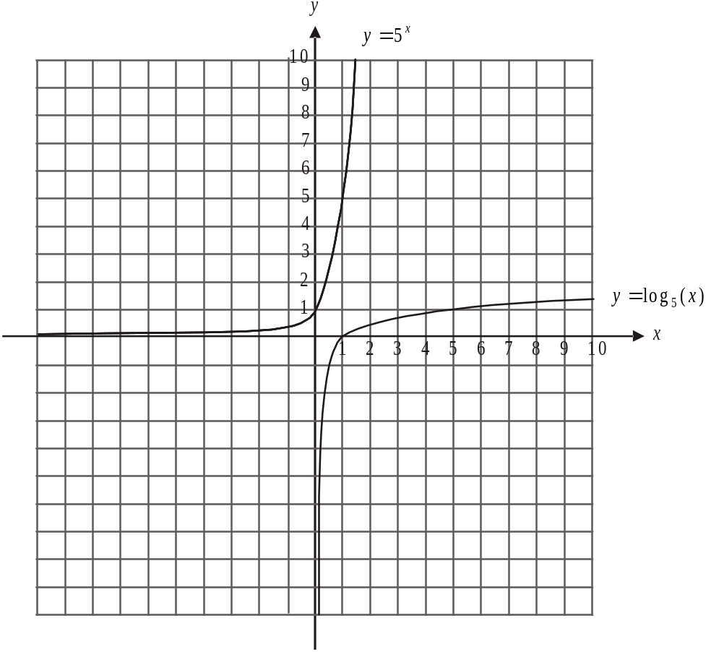

(1 mark) – correct shape including
asymptotic behaviour as
(1mark) correct x intercept of 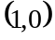

- The function 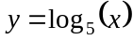 is the inverse function of the function 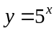. Its graph therefore is a reflection of the graph of in the line .
(1mark)

Question 6

Method 1
Draw a probability table.
Let J represent the event of studying Japanese.
Let M represent the event of being male.

 | M | 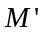
J | 0.09 | 0.03 | 0.12
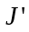 | 0.34 | 0.54 | 0.88
 | 0.43 | 0.57 | 1

- 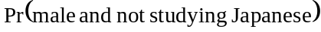
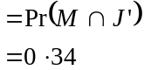
(1 mark)

- 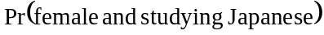
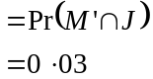
(1 mark)

- 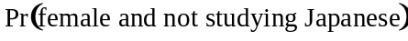
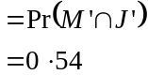
(1 mark)

- 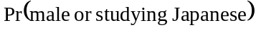
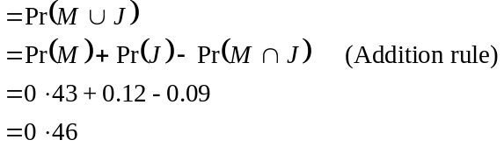
(1 mark) – where some attempt is
made to use the addition rule
(1 mark) – correct answer

Method 2

Draw a Venn Diagram.
Let J represent the event of studying Japanese.
Let M represent the event of being male.

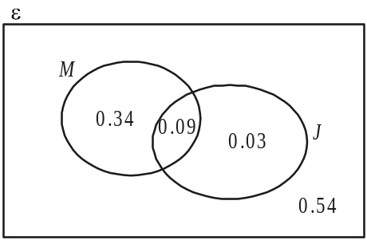

a.
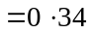
(1 mark)

b.
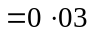
(1 mark)

c.
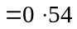
(1 mark)

d.
(1 mark)
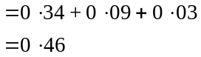

(1 mark) – correct answer

Question 7

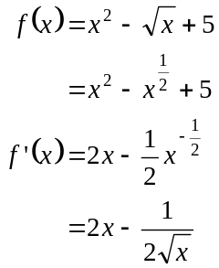
(1 mark) – for correctly differentiating
the 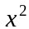 term and the constant term
(1 mark) – for correctly differentiating
the 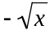 term

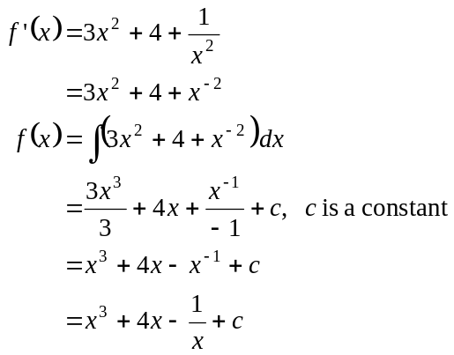
(1 mark) – for correctly antidifferentiating
the 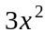 term and the constant term
(1 mark) – for correctly antidifferentiating
the 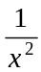 term

Question 8

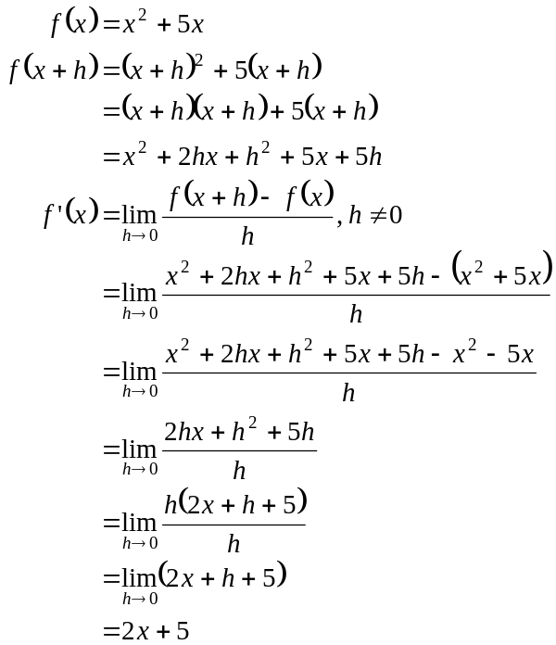
(1 mark)
(1 mark)
(1 mark)
(Note: not all of the above steps need to be included – they are included here so that the simplification is made clear.)

Question 9

- The graphs intersect when
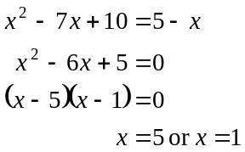
(1 mark)
Substitute these values into either 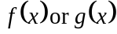 or both if you have time.
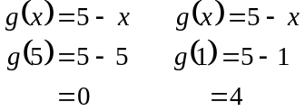
The points are 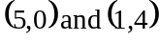.
(1 mark)
(Check – if time
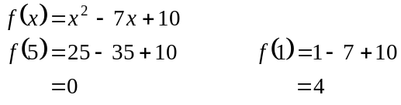
The points are 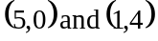.)

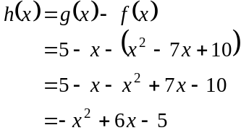

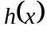 is greatest, i.e. a maximum,
(1 mark)
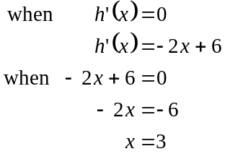
(1 mark)
The greatest value of 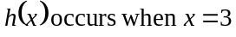.
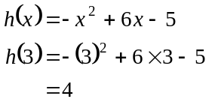
(1 mark)
So the greatest difference between the values of 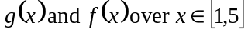 is 4 and it occurs when .
(Check from your graph that this answer is feasible i.e. at , does the difference between 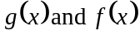 look the greatest?)

Question 10
The graph of 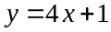 is a straight line with a gradient of 4.
The gradient of the graph of 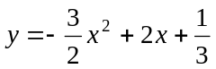
is given by 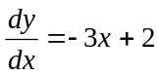.
(1 mark)
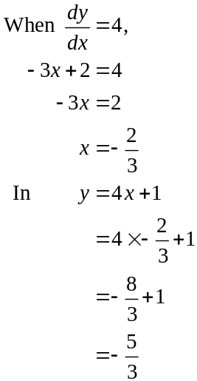
(1 mark)
(Alternatively substitute 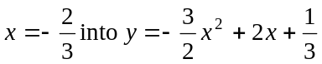, but the arithmetic is harder.)
So the point A is 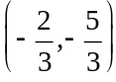. (1 mark)

Question 11
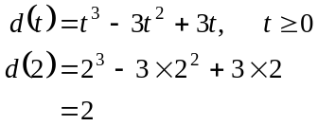

The particle is 2 metres from its origin of motion.
(1 mark)

- The average rate of change of displacement of the particle between is given by
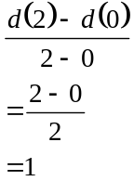
The average rate of change between is 1 m/s.
(1 mark)

- The instantaneous rate of change at is given by 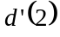 i.e. the gradient of the function at .
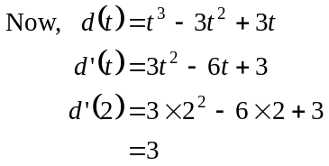
(1 mark)
At , the instantaneous rate of change is 3 m/s.
(1 mark)

- The particle is stationary when 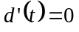. (1 mark)
From part c.
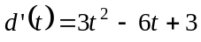
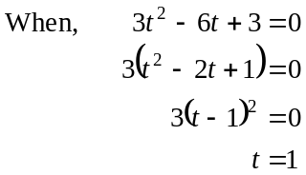
The particle is stationary at sec. (1 mark)
(Note, it is only momentarily stationary.)

Total 40 marks

